LARS System Accembly and Parts

**LASER:**

The laser is a Teem Photonics STV-01E-140. This is a 355nm laser. This is connected to a Laser Controller MLC-03A-DP1. This laser controller has two parts that need to be added that are not talked about much in the manual. The first part we will cover is the **50 Ohms resistor** this is the part circled in purple. The laser will not produce a “true” beam until this is added.



The second part is the Utility Cable (SV81). This cable will allow the wave generator to communicate with the laser system. This connector has to be order <https://uk.rs-online.com/web/p/din-connectors/5336792> . You will use a BNC cable. Cut one end exposing the cables inside. The inner wire is your hot wire and the metal coating on the outside of this is your ground. The inner wire of the BNC will connect to pin 2 on the SV81. Then pin 4 of the SV81 will connect to the ground of the BNC.

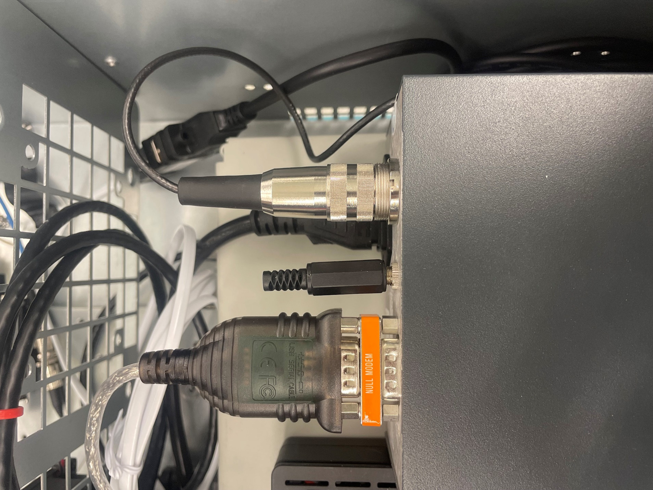



In this picture above you will see a cable connected to a null modem. This is a RS-323 cable has a **Prolific Chip. *Only RS-323 cables with a Prolific Chip will be able to communicate with the laser.*** This cable will need a Null modem add to it. If not the laser and Raspberry Pi will not be able to communicate properly. The part circled in orange is for the interlock this need to remain plugged in or the laser will not be able to beam.

***Testing the laser:***

There is a way to run a test on your laser system. You will need a pc/ laptop connect the RS323 cable to your pc/laptop. Have PuTTy installed. Go to Device Manager on your pc/laptop find what port the laser is talking to (mine was COM4). Set PuTTy to serial connection and set it up to how the cable is seen in Device Manager. You will most likely need to switch the speed to **19200** and flow control to **NONE.** You will then insert the key into the front of the laser and turn it until the laser system lights start to turn on. On the screen produced by PuTTy you should see the test be carried out by the laser make sure everything is successfully. If not need to contact manufacturer.

**Raspberry PI:**

The Raspberry Pi should look like this after all cables are connected. Laser controller should be to the top right. The attenuator should be in the bottom right USB port. The wave generator should have its USB to ethernet connection to the top left.

**Attenuator:**

For this project we found the Attenuator will work with a Rs-323 cable with FTDI Chip. We chose this type of RS-323 for communication links. The Attenuator requires a 12V power supplies. You will need to order a DC power jack plug adapter barrel connector. You can find them on almost anywhere or @ <https://www.amazon.com/California-JOS-Male-Female-2-1x5-5mm/dp/B0CR8TZ41W/ref=sr_1_6?crid=2GZA3TU0JUM5P&dib=eyJ2IjoiMSJ9.0jrbrstxRMD4t88Ijts-2zQb8Vr7oC0cnp5_A-iXGscm3kowlDKbQfIX3m_wHhvigRNNuVTBTlV3VhQGBCValys3ki-y0KhLCBeJex-lRo7XOaseXRUY94cZowTbI09wOclbufAx2Gs4YrRd849sLLjhlcycBh7OAWn2MCuG4k6BIuNTXEGjRfv0PuXK67sEQxVIbeeVD8x7NJbzkLFwkOAWnmdrNtJb8H_tgDJH5JI.39mo-YY0pTh3F8AtD4_2mhArhskQ6HI0jqJNCesMDRc&dib_tag=se&keywords=12v+power+adaptor+to+wire&qid=1731615979&sprefix=12v+power+adaptor+to+wire%2Caps%2C90&sr=8-6>.

You will need to connect the stray wires from the Attenuator to this adapter like the picture below. **Purple and red wire will go into one. While the ground (black) will be alone.** 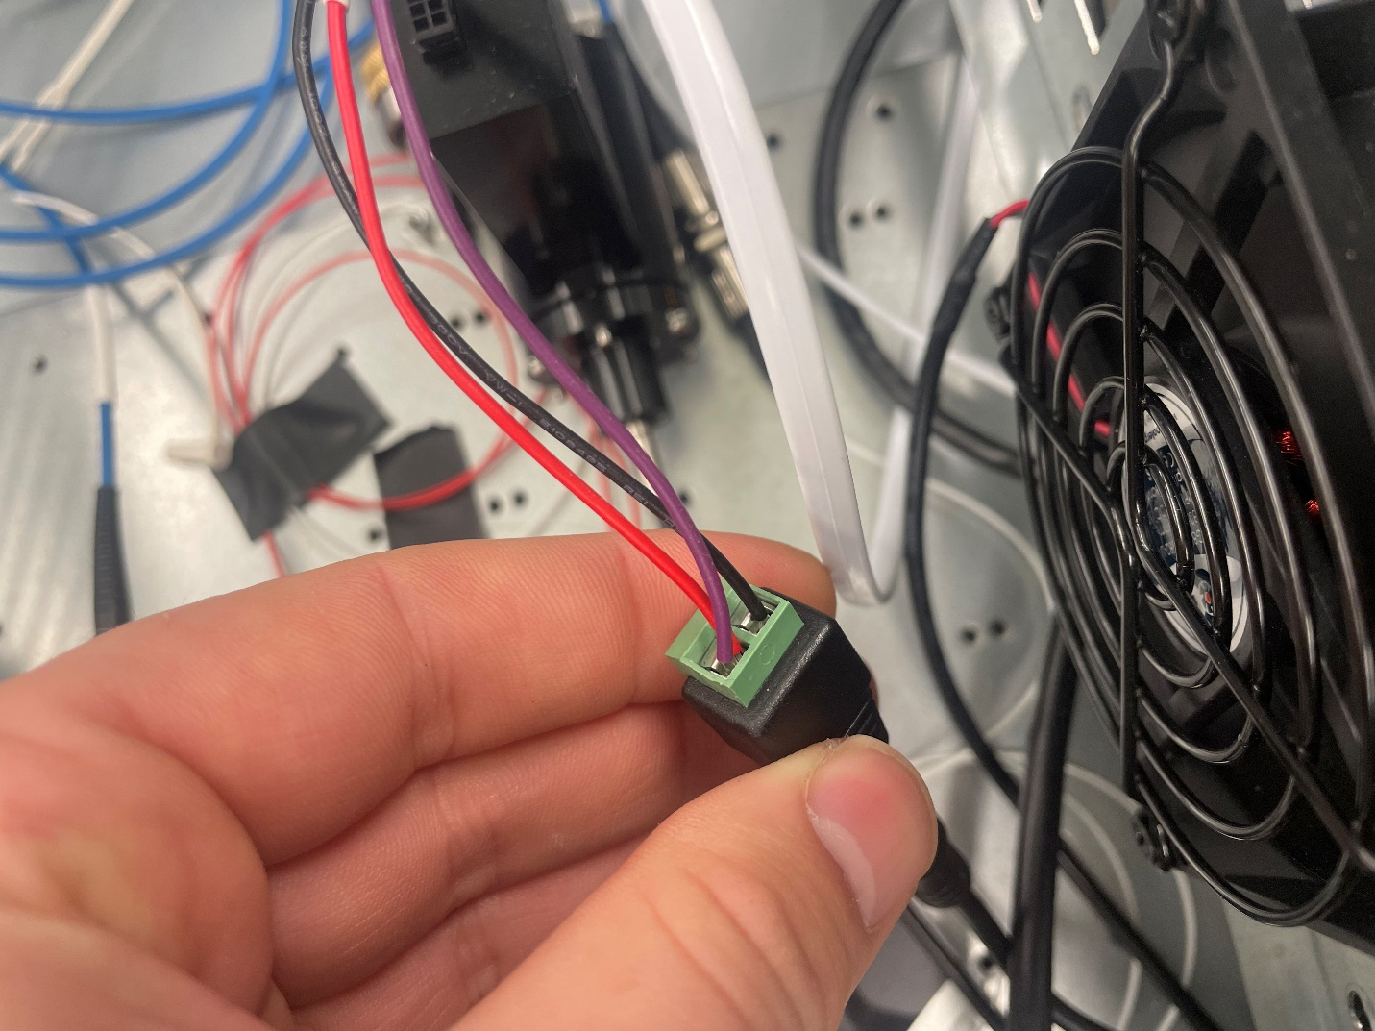

**Optic Fiber:**

For this project we had to special order different fibers than that in the BAND system. These fibers are FG105ACA 105um .22NA. You can make the fiber @ <https://www.thorlabs.com/newgrouppage9.cfm?objectgroup_id=2410>. The fiber setting are MM, FG105ACA- (.22NA, 250-1200 nm; 105 um Core) both connectors need to be FC/PC with Ceramic Ferrule. Example of the cable is given in the picture below.

**How to wire it all up:**

Here is the wiring schematic made by Carlos Gayoso. This is how everything should be connected in the system.

**Photos of our system**

